

Mini Project Phase 2

COE451: Computer & Network Security

Term 202

Dr: Marwan Abu-Amar

Student: Osama Bujwaied

ID: 201661700

**First Program**

I took it from the internet, but unfortunately it did not work in Windows 7 VirtualBox

Code source:

https://github.com/aidHadzic/Tic-Tac-Toe-server-client/blob/master/src/tictactoeserver/NewSession.javaMake sure to understand the code very well, and to test it preferably using 2 virtual machines

Picture

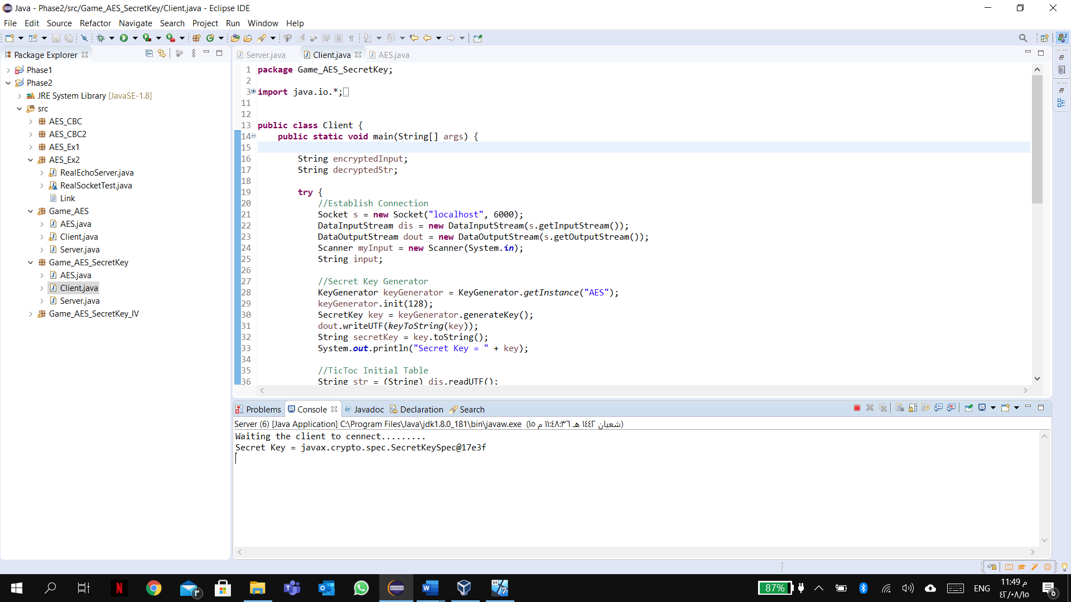

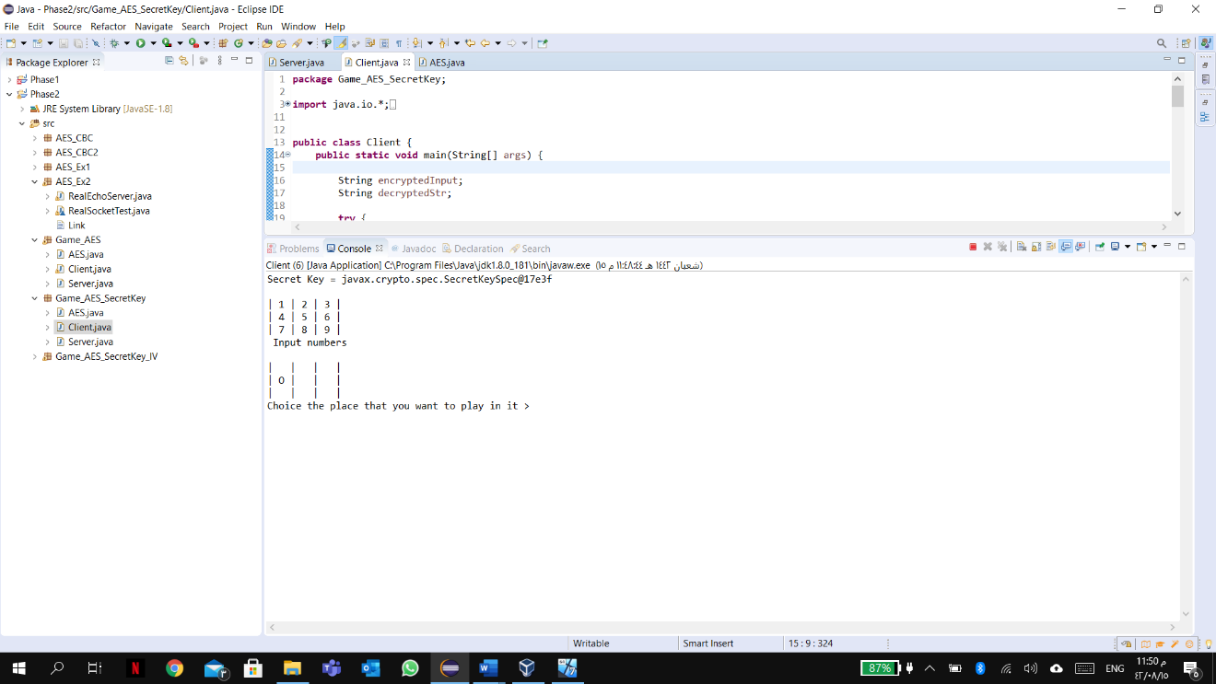

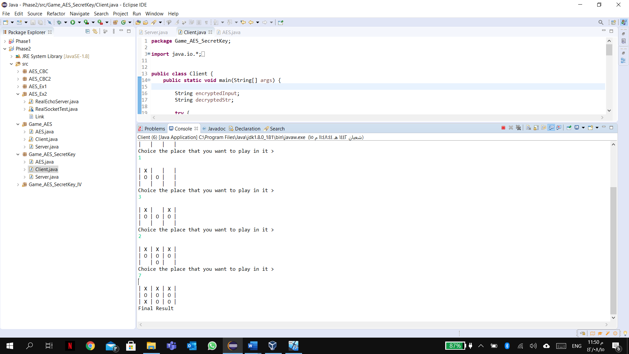

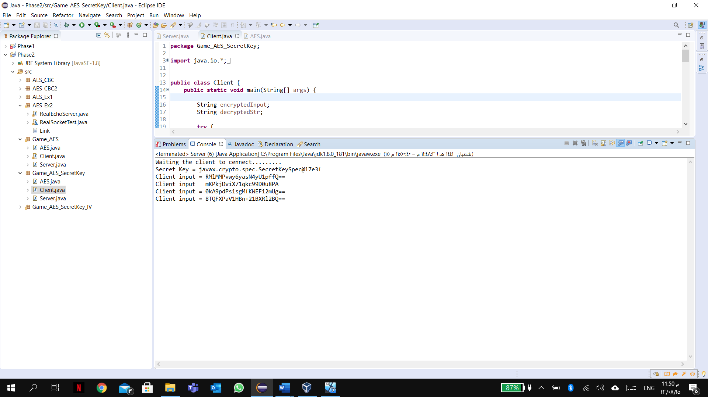

Unfortunately Java in VirtualBox did not work

